EVALUATING RESULTS AND DRAWING CONCLUSIONS

When evaluating results and drawing conclusions from experimental measurements, you can identify anomalies by looking for data points that don't fit the trend or other replicates. Anomalous results are often more than 10% different from the mean.
Here are some tips for evaluating results and drawing conclusions:
- Identify anomalies
Experimental errors (also known as operator errors or ‘one off’ errors) will affect the results of an experiment and can produce anomalies
  - These anomalies should be identified during the evaluation of results and before drawing conclusions
  - Anomalies can be identified by looking for results or data points on a graph that do not fit with the trend or with other replicates carried out during the experiment.
  - These anomalous results will show a larger difference from the mean than the rest of the results (a result is often taken to be anomalous if it differs from the mean result by more than 10%). Anomalous results can be removed and repeated to make the results more reliable. If an anomaly occurs in the experiment ignore this value when calculating the mean.
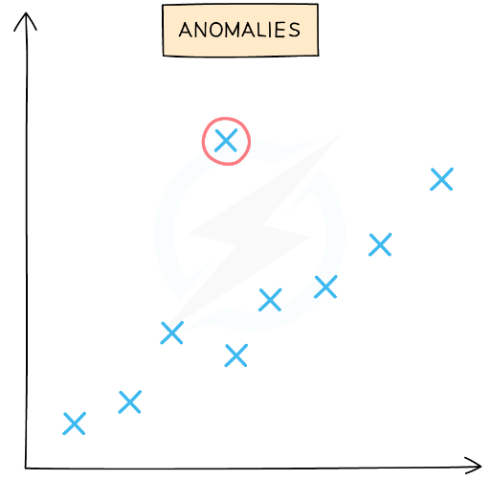

- Consider the quality of the data
Evaluate the precision, repeatability, reproducibility, accuracy, and confidence in the accuracy of the results.
- Repeat the experiment
Repeat the experiment at least twice to obtain concordant results and discount anomalies. The results or ‘data’ collected from an experiment can be made more reliable if the experiment is repeated several times and anomalies are removed
  - This, in turn, allows more valid conclusions to be drawn

- Consider random errors
Random errors are unpredictable changes in the experiment that can be reduced by increasing the amount of data.
- Consider gross personal errors
Gross personal errors, also called mistakes or blunders, should be avoided and corrected if discovered.
- Write a conclusion
In your conclusion, briefly restate the purpose of the experiment, identify the main findings, and note the main limitations.
- Consider the effect of weaknesses and improvements
Include at least 3 weaknesses and 3 improvements, and discuss the effect of each on the results

Complete Guide to Errors and Uncertainties for A Level Physics | Vivax Solutions
Calculating Uncertainties | AQA A Level Physics Revision Notes 2015

Errors and Mistakes
Suppose you are carrying out an experiment involving a simple pendulum inside a lab, while measuring the length of the pendulum and the time period. Just imagine that it's windy outside and you forgot to close a window properly in the vicinity, while inadvertently letting a mild draught in. Afterwards, someone points out the effect of draught on the experiment. In this case, you made a mistake.
Now, you make a decision to repeat the experiment while rectifying the mistake - by closing the window properly. So, mistakes are avoidable and can, in most cases, be rectified easily.
An error, on the other hand, is the difference between the real value and the experimental value. Errors stem from the faulty devices used in the experiments as well as flawed designs of the experiments. They are inevitable and all we can do is to keep them to a minimum.
In short, mistakes are not errors; there is a clear distinction between the two.
Measurement Errors
The true value is a value that you obtain from a data book or from an experiment in ideal conditions. It is certainly going to be different from a measured value. The difference between the true value and the measured value is a measurement error.
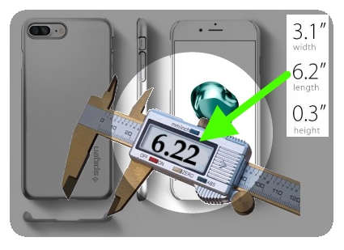
E.g.

In the above image, a smartphone manufacturer gives us the length, width and height of the phone. We take them for granted by assuming they are true values. However, if we measure them, say, with a Vernier calliper, the measured values may not be the same. So, the differences between the true values and measured values, in this case, constitute measurement errors.
There are two types of measurement errors:
- Random Errors
- Systematic Errors
Random Errors
Random errors occur when measurements are being made; as a result, the measurements may vary in unpredictable ways, which could result in a significant deviation from the true value.
E.g.
Let's say a resistor, bought from an electronic shop, shows that its resistance is 12Ω. If we measure it by a multimeter, it may show values such as 12.5, 13, 13.7 or even 14. The variation in measurements may be due to:
- The change in the temperature due to the current
- The difficulty in taking the measurement from the multimeter
Since the control of both factors are beyond us, it is clear that random errors cannot be corrected. All we can do is making more measurements and then finding the mean of them. In addition, we can make use of high-resolution equipment and resort to data-logging with the aid of a computer to deal with random errors.
Systematic Errors
Systematic errors, by contrast, occur when measurements are being made and the error values may seem to be consistent during the period in which the experiment is carried out.
E.g.
A thermometer placed inside a hole of a warming iron block may not record the correct temperature due to the following:
- Poor contact between the thermometer bulb and the surface of iron.
- A fault in the the scale of the thermometer - without resting at 0C⁰, when placed in melting ice.
As you can see, unlike random errors, systematic errors can be corrected; in order to rectify the above errors, we can do the following:
- Filling the hole with mercury in order to make a good contact between the thermometer bulb and the iron block.
- Using a thermometer that has a reliable scale attached to it.

Uncertainty
The interval in which the true value lies is called the uncertainty in the measurement.
There is always a degree of uncertainty when measurements are taken; the uncertainty can be thought of as the difference between the actual reading taken (caused by the equipment or techniques used) and the true value
- Uncertainties are not the same as errors
  - Errors can be thought of as issues with equipment or methodology that cause a reading to be different from the true value
  - The uncertainty is a range of values around a measurement within which the true value is expected to lie, and is an estimate
For example, if the true value of the mass of a box is 950 g, but a systematic error with a balance gives an actual reading of 952 g, the uncertainty is ±2 g
These uncertainties can be represented in a number of ways:
  - Absolute Uncertainty: where uncertainty is given as a fixed quantity
  - Fractional Uncertainty: where uncertainty is given as a fraction of the measurement
  - Percentage Uncertainty: where uncertainty is given as a percentage of the measurement
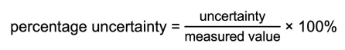

To find uncertainties in different situations:
- The uncertainty in a reading: ± 1 the smallest division
- The uncertainty in a measurement: at least ± half smallest division
- The uncertainty in repeated data: half the range i.e. ± ½ (largest - smallest value)
- The uncertainty in digital readings: ± the last significant digit unless otherwise quoted

E.g.
1. Suppose the measurements of the diameter of a pin by a Vernier Calliper are as follows:
0.25mm; 0.24mm;0.26mm; 0.23mm;0.27mm;
The mean = (0.25 + 0.24 + 0.26 + 0.23 + 0.27)/5 =125/5 = 0.25mm
The range = 0.27 - 0.23 = 0.04mm
Absolute Uncertainty = ± 0.04/2 = ± 0.02
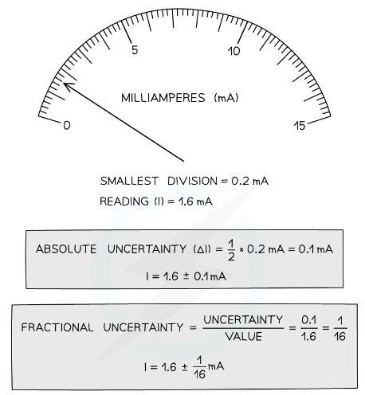
So, the mean value = mean ± range/2
= 0.25 ± 0.04/2
= 0.25 ± 0.02mm

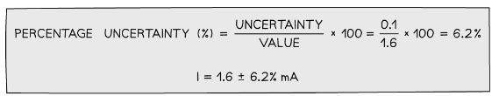

Combining Uncertainties
When combining uncertainties, the rules are as follows:
Adding / Subtracting Data
- Add together the absolute uncertainties
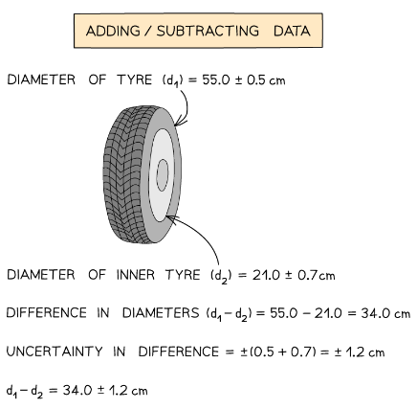

Multiplying / Dividing Data
Add the percentage or fractional uncertainties
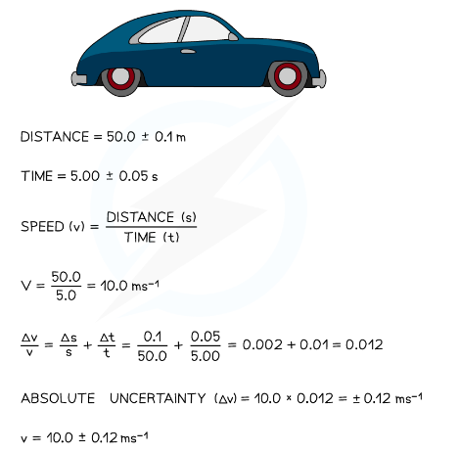

Raising to a Power
- Multiply the percentage uncertainty by the power

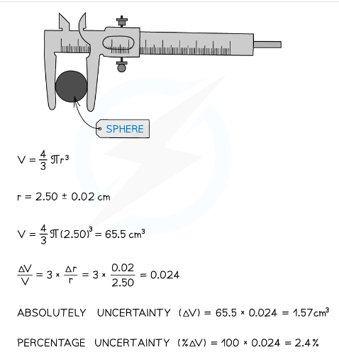

Worked Example
A student achieves the following results in their experiment for the angular frequency, ω.
0.154, 0.153, 0.159, 0.147, 0.152
Calculate the percentage uncertainty in the mean value of ω.
Answer:
Step 1: Calculate the mean value
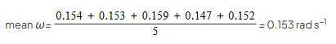

Step 2: Calculate half the range (this is the uncertainty for multiple readings)
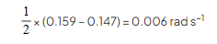

Step 3: Calculate percentage uncertainty
